**Question 1:** A pentagonal prism of base side 20 mm and axis of 50 mm long rests with one of the edges of the base on HP. Its axis is inclined at 30˚ to HP and parallel to VP. It is cut by a horizontal plane passing through the highest corner of the base. Draw the sectional top view.

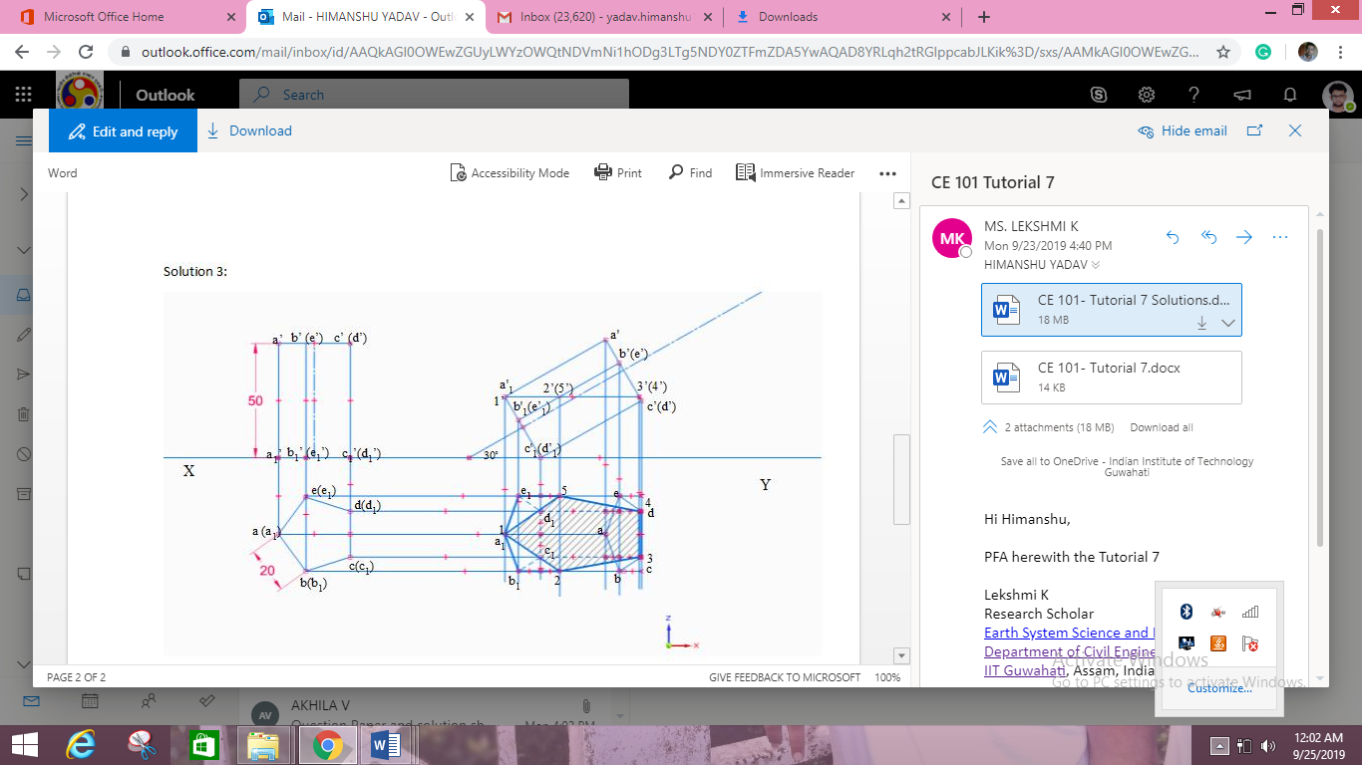

**Question 2:** A Square prism, side of base 40 mm and axis 80 mm long, rests with its base on HP and one of its rectangular faces is inclined at 45° to VP. A section plane perpendicular to VP and inclined at 60° to HP cuts the axis of the prism at a point 30 mm from its top end. Draw the sectional top view and true shape of the section.

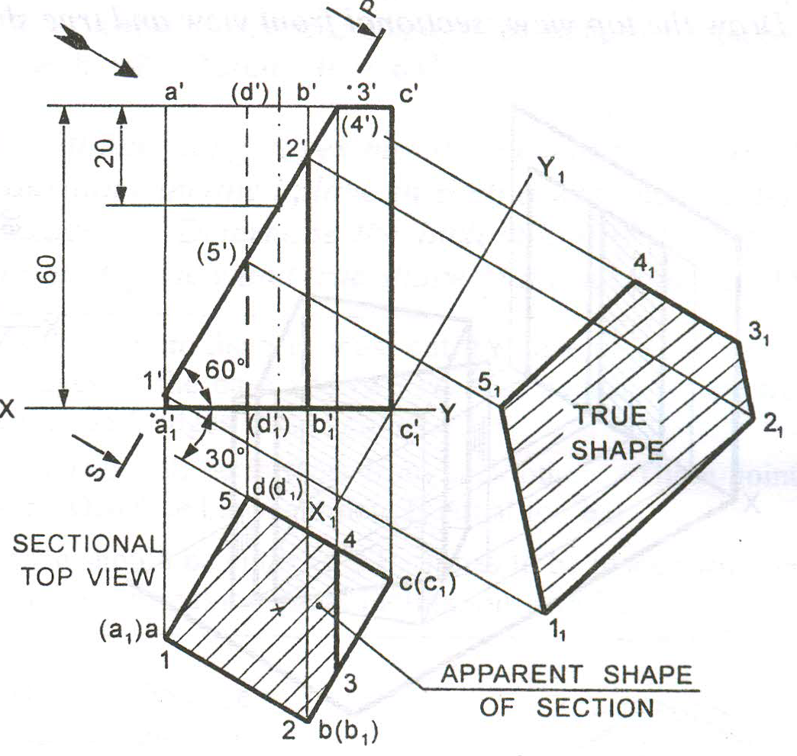

**Question 3:** A cone base 70 mm diameter and axis 80 mm long is resting on its base on HP. It is cut by a section plane perpendicular to the VP, inclined at 60º to the HP and cutting the axis at a point 30 mm from the apex. Draw the front view, sectional top view, sectional side view and true shape of the section.

